Soumya suryawanshi 24070521062 (Software Copy - Experiment 4)
1. Experiment Title
Use Function Types, Scope, Closures, Try-Catch Exception Handling, and Build a Palindrome Checker
2. Software / Tools Required
Visual Studio Code
HTML5
CSS3
JavaScript
Google Chrome
3. Experiment Program Code

index.html
<!DOCTYPE html>
<html lang="en">
<head>
<meta charset="UTF-8">
<meta name="viewport" content="width=device-width, initial-scale=1.0">
<title>Palindrome Checker | Glassmorphism</title>
<link rel="stylesheet" href="style.css">
</head>
<body>
<div class="background-mesh">
<div class="orb orb-1"></div>
<div class="orb orb-2"></div>
</div>

<div class="glass-card">
<div class="card-header">
<h1>Palindrome Checker</h1>
<p id="heading"></p>
</div>

<div class="input-group">
<input
type="text"
id="word"
placeholder="Enter a word (e.g., racecar)"
autocomplete="off"
aria-label="Word to check">

<button onclick="checkPalindrome()" class="glass-btn">
<span>Check</span>
<div class="btn-shine"></div>
</button>
</div>

<div id="result" class="result-area" aria-live="polite"></div>
</div>

<script src="script.js"></script>
</body>
</html>

style.css
:root {
/* Modern Color Palette using oklch for better vibrancy */
--color-bg-1: oklch(0.2 0.1 260);
--color-bg-2: oklch(0.3 0.15 320);
--color-glass-bg: oklch(1 0 0 / 0.1);
--color-glass-border: oklch(1 0 0 / 0.2);
--color-glass-highlight: oklch(1 0 0 / 0.5);
--color-text-main: oklch(0.95 0 0);
--color-text-muted: oklch(0.7 0 0);
--color-success: oklch(0.7 0.15 150);
--color-error: oklch(0.6 0.15 25);

/* Spacing & Radius */
--radius-lg: 24px;
--radius-md: 12px;
--blur-strength: 16px;
}

* {
box-sizing: border-box;
margin: 0;
padding: 0;
}

body {
font-family: 'Inter', system-ui, -apple-system, sans-serif;
background-color: #0f0f13;
min-height: 100vh;
display: flex;
justify-content: center;
align-items: center;
overflow: hidden;
color: var(--color-text-main);
}

/* Animated Background Mesh */
.background-mesh {
position: absolute;
top: 0;
left: 0;
width: 100%;
height: 100%;
z-index: -1;
filter: blur(80px);
opacity: 0.6;
}

.orb {
position: absolute;
border-radius: 50%;
animation: float 10s infinite ease-in-out;
}

.orb-1 {
width: 400px;
height: 400px;
background: var(--color-bg-1);
top: -100px;
left: -100px;
animation-delay: 0s;
}

.orb-2 {
width: 300px;
height: 300px;
background: var(--color-bg-2);
bottom: -50px;
right: -50px;
animation-delay: -5s;
}

@keyframes float {
0%, 100% {
transform: translate(0, 0) scale(1);
}

33% {
transform: translate(30px, -50px) scale(1.1);
}

66% {
transform: translate(-20px, 20px) scale(0.9);
}
}

/* Glassmorphism 2.0 Card */
.glass-card {
width: 90%;
max-width: 420px;
padding: 2.5rem;
border-radius: var(--radius-lg);

background: var(--color-glass-bg);
backdrop-filter: blur(var(--blur-strength)) saturate(180%);
-webkit-backdrop-filter: blur(var(--blur-strength)) saturate(180%);

border: 1px solid var(--color-glass-border);
border-top: 1px solid var(--color-glass-highlight);
border-left: 1px solid var(--color-glass-highlight);

box-shadow:
0 8px 32px 0 rgba(0, 0, 0, 0.3),
inset 0 0 0 1px rgba(255, 255, 255, 0.05);

text-align: center;
position: relative;
overflow: hidden;
transform: translateZ(0);
transition: transform 0.3s ease, box-shadow 0.3s ease;
}

.glass-card:hover {
transform: translateZ(0) translateY(-5px);

box-shadow:
0 12px 40px 0 rgba(0, 0, 0, 0.4),
inset 0 0 0 1px rgba(255, 255, 255, 0.1);
}

h1 {
font-size: 1.75rem;
font-weight: 700;
margin-bottom: 0.5rem;
letter-spacing: -0.02em;
background: linear-gradient(135deg, #fff 0%, #e0e0e0 100%);
-webkit-background-clip: text;
-webkit-text-fill-color: transparent;
}

#heading {
color: var(--color-text-muted);
font-size: 0.9rem;
margin-bottom: 2rem;
font-weight: 400;input-group {
:root {
/* Modern Color Palette using oklch for better vibrancy */
--color-bg-1: oklch(0.2 0.1 260);
--color-bg-2: oklch(0.3 0.15 320);
--color-glass-bg: oklch(1 0 0 / 0.1);
--color-glass-border: oklch(1 0 0 / 0.2);
--color-glass-highlight: oklch(1 0 0 / 0.5);
--color-text-main: oklch(0.95 0 0);
--color-text-muted: oklch(0.7 0 0);
--color-success: oklch(0.7 0.15 150);
--color-error: oklch(0.6 0.15 25);

/* Spacing & Radius */
--radius-lg: 24px;
--radius-md: 12px;
--blur-strength: 16px;
}

* {
box-sizing: border-box;
margin: 0;
padding: 0;
}

body {
font-family: 'Inter', system-ui, -apple-system, sans-serif;
background-color: #0f0f13;
min-height: 100vh;
display: flex;
justify-content: center;
align-items: center;
overflow: hidden;
color: var(--color-text-main);
}

/* Animated Background Mesh */
.background-mesh {
position: absolute;
top: 0;
left: 0;
width: 100%;
height: 100%;
z-index: -1;
filter: blur(80px);
opacity: 0.6;
}

.orb {
position: absolute;
border-radius: 50%;
animation: float 10s infinite ease-in-out;
}

.orb-1 {
width: 400px;
height: 400px;
background: var(--color-bg-1);
top: -100px;
left: -100px;
animation-delay: 0s;
}

.orb-2 {
width: 300px;
height: 300px;
background: var(--color-bg-2);
bottom: -50px;
right: -50px;
animation-delay: -5s;
}

@keyframes float {
0%, 100% {
transform: translate(0, 0) scale(1);
}

33% {
transform: translate(30px, -50px) scale(1.1);
}

66% {
transform: translate(-20px, 20px) scale(0.9);
}
}

/* Glassmorphism 2.0 Card */
.glass-card {
width: 90%;
max-width: 420px;
padding: 2.5rem;
border-radius: var(--radius-lg);

background: var(--color-glass-bg);
backdrop-filter: blur(var(--blur-strength)) saturate(180%);
-webkit-backdrop-filter: blur(var(--blur-strength)) saturate(180%);

border: 1px solid var(--color-glass-border);
border-top: 1px solid var(--color-glass-highlight);
border-left: 1px solid var(--color-glass-highlight);

box-shadow:
0 8px 32px 0 rgba(0, 0, 0, 0.3),
inset 0 0 0 1px rgba(255, 255, 255, 0.05);

text-align: center;
position: relative;
overflow: hidden;
transform: translateZ(0);
transition: transform 0.3s ease, box-shadow 0.3s ease;
}

.glass-card:hover {
transform: translateZ(0) translateY(-5px);

box-shadow:
0 12px 40px 0 rgba(0, 0, 0, 0.4),
inset 0 0 0 1px rgba(255, 255, 255, 0.1);
}

h1 {
font-size: 1.75rem;
font-weight: 700;
margin-bottom: 0.5rem;
letter-spacing: -0.02em;
background: linear-gradient(135deg, #fff 0%, #e0e0e0 100%);
-webkit-background-clip: text;
-webkit-text-fill-color: transparent;
}

#heading {
color: var(--color-text-muted);
font-size: 0.9rem;
margin-bottom: 2rem;
font-weight: 400;
}

script.js
function reverseString(str) {
return str.split("").reverse().join("");
}

function message() {
const msg = "Palindrome Checker";
return () => msg;
}

// Initialize heading using closure
const showMessage = message();
document.getElementById("heading").innerText = showMessage();

function checkPalindrome() {
const wordInput = document.getElementById("word");
const resultEl = document.getElementById("result");
const word = wordInput.value.trim();

// Reset previous state
resultEl.className = "result-area";
resultEl.innerText = "";

try {
if (!word) {
throw new Error("Please enter a word.");
}

const reversed = reverseString(word);
const isPalindrome = word.toLowerCase() === reversed.toLowerCase();

if (isPalindrome) {
showResult(`"${word}" is a Palindrome!`, "success");
} else {
showResult(`"${word}" is Not a Palindrome.`, "error");
}

} catch (error) {
showResult(error.message, "info");
wordInput.focus();
}
}

function showResult(text, type) {
const resultEl = document.getElementById("result");
resultEl.innerText = text;
resultEl.className = `result-area ${type} visible`;
}

// Allow Enter key to trigger palindrome check
document.getElementById("word").addEventListener("keypress", function (event) {
if (event.key === "Enter") {
checkPalindrome();
}
});

4. Output
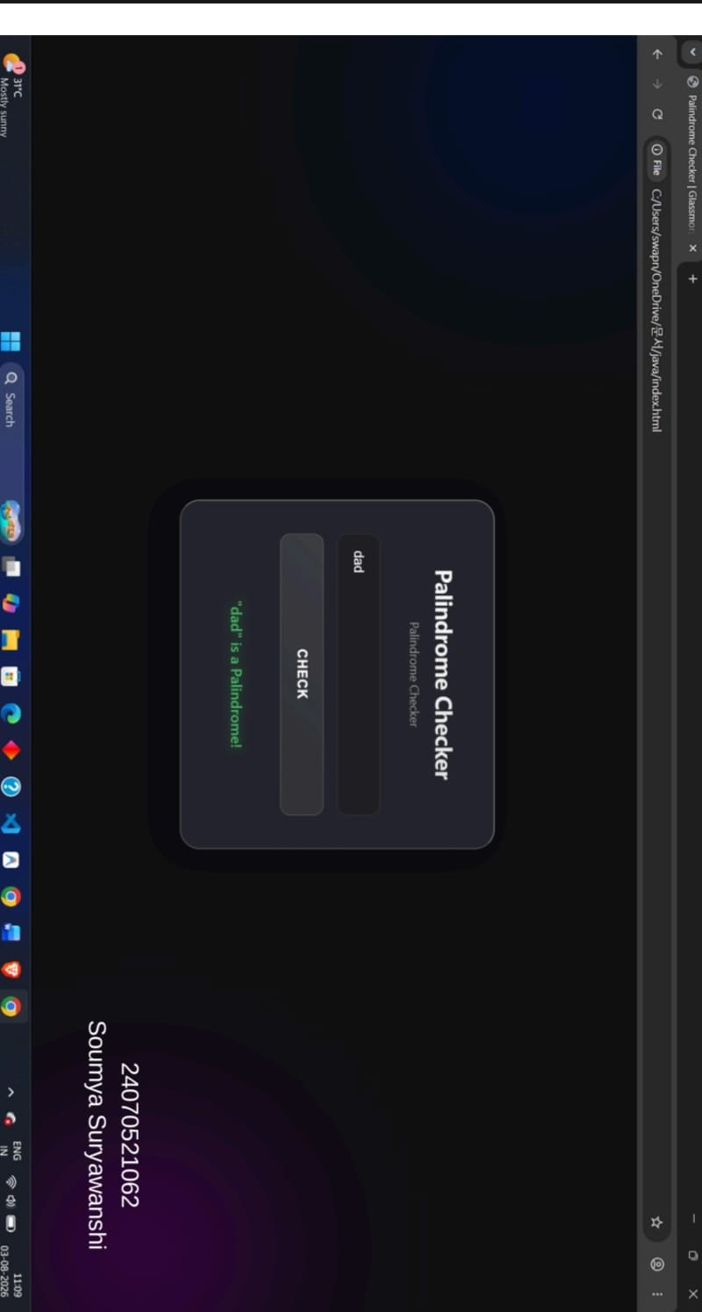
5. Case Study Title
Vehicle number Validation checker
6. Case Study Program Cod
index.html
<!DOCTYPE html>
<html lang="en">
<head>
<meta charset="UTF-8">
<meta name="viewport" content="width=device-width, initial-scale=1.0">
<title>Sarathi Parivahan - Vehicle Registration Validation</title>

<link rel="stylesheet" href="style.css">

<link href="https://fonts.googleapis.com/css2?family=Roboto:wght@400;500;700&display=swap" rel="stylesheet">
</head>

<body>

<div class="govt-container">

<header class="govt-header">

<div class="emblem-section">
<img
src="https://upload.wikimedia.org/wikipedia/commons/5/55/Emblem_of_India.svg"
alt="Emblem of India"
class="national-emblem">
</div>

<div class="header-text">
<h1>Ministry of Road Transport and Highways</h1>
<h2>Department of Road Transport</h2>
<h3>Sarathi Parivahan Sewa</h3>

<p class="subtitle">
Vehicle Registration Number Validation Service
</p>
</div>

</header>

<div class="content-wrapper">

<div class="form-panel">

<div class="panel-header">
<h4>Online Vehicle Registration Validation</h4>
</div>

<div class="form-body">

<p class="instruction-text">
Please enter the Vehicle Registration Number to validate
its format against Indian standards.
</p>

<div class="input-group">

<label
for="registrationInput"
class="form-label">

Vehicle Registration Number

</label>

<div class="input-control-wrapper">

<input
type="text"
id="registrationInput"
placeholder="e.g. MH31AB1234"
maxlength="10"
class="form-input">

<button
id="validateBtn"
class="govt-btn">

Validate Now

</button>

</div>

</div>

<div
id="result"
class="result-box hidden"
role="alert">

</div>

<div class="info-box">

<h5>Validation Criteria:</h5>

<ul class="criteria-list">

<li>
Format:
<strong>XX 00 XX 0000</strong>
(State-District-Series-Number)
</li>

<li>
First 2 characters:
State Code (Alphabets)
</li>

<li>
Next 2 characters:
District Code (Digits)
</li>

<li>
Next 2 characters:
Series Code (Alphabets)
</li>

<li>
Last 4 characters:
Unique Vehicle Number (Digits)
</li>

</ul>

</div>

</div>

</div>

</div>

<footer class="govt-footer">

<p>
&copy; 2026 Ministry of Road Transport and Highways,
Govt of India.
</p>

<p class="footer-note">
System generated validation for informational purposes only.
</p>

</footer>

</div>

<script src="script.js"></script>

</body>
</html>

style.css
:root {
--govt-blue: #1a4d8c;
--govt-dark-blue: #0f2d52;
--govt-saffron: #ff9933;
--govt-green: #138808;
--bg-light: #f0f2f5;
--text-dark: #333333;
--text-muted: #555555;
--border-color: #cccccc;
--white: #ffffff;
--success-bg: #e8f5e9;
--success-text: #2e7d32;
--success-border: #4caf50;
--error-bg: #ffebee;
--error-text: #c62828;
--error-border: #ef5350;
}

* {
box-sizing: border-box;
margin: 0;
padding: 0;
}

body {
font-family: 'Roboto', Arial, sans-serif;
background-color: var(--bg-light);
color: var(--text-dark);
line-height: 1.6;
display: flex;
justify-content: center;
align-items: center;
min-height: 100vh;
padding: 20px;
}

.govt-container {
width: 100%;
max-width: 700px;
background: var(--white);
box-shadow: 0 4px 12px rgba(0,0,0,0.1);
border: 1px solid var(--border-color);
}

/* Header Section */

.govt-header {
background: linear-gradient(
to right,
var(--govt-blue),
var(--govt-dark-blue)
);
color: var(--white);
padding: 20px 30px;
display: flex;
align-items: center;
border-bottom: 4px solid var(--govt-saffron);
}

.national-emblem {
width: 60px;
height: auto;
margin-right: 20px;
filter: brightness(0) invert(1);
}

.header-text h1 {
font-size: 1.2rem;
font-weight: 700;
text-transform: uppercase;
letter-spacing: 0.5px;
margin-bottom: 4px;
}

.header-text h2 {
font-size: 1rem;
font-weight: 500;
margin-bottom: 2px;
opacity: 0.9;
}

.header-text h3 {
font-size: 1.4rem;
font-weight: 700;
margin-bottom: 4px;
color: var(--govt-saffron);
}

.subtitle {
font-size: 0.9rem;
font-style: italic;
opacity: 0.8;
}

/* Content & Form */

.content-wrapper {
padding: 30px;
}

.form-panel {
border: 1px solid var(--border-color);
border-radius: 4px;
background: #fff;
}

.panel-header {
background-color: #f8f9fa;
padding: 12px 15px;
border-bottom: 1px solid var(--border-color);
border-radius: 4px 4px 0 0;
}

.panel-header h4 {
color: var(--govt-blue);
font-size: 1.1rem;
font-weight: 700;
text-transform: uppercase;
}

.form-body {
padding: 25px;
}

.instruction-text {
font-size: 0.95rem;
color: var(--text-muted);
margin-bottom: 20px;
}

.input-group {
margin-bottom: 25px;
}

.form-label {
display: block;
font-weight: 600;
margin-bottom: 8px;
color: var(--text-dark);
font-size: 1rem;
}

.input-control-wrapper {
display: flex;
gap: 15px;
flex-wrap: wrap;
}

.form-input {
flex: 1;
padding: 10px 12px;
font-size: 1rem;
border: 1px solid var(--border-color);
border-radius: 2px;
background-color: #fafafa;
text-transform: uppercase;
min-width: 200px;
}

.form-input:focus {
outline: none;
border-color: var(--govt-blue);
box-shadow: 0 0 0 2px rgba(26,77,140,0.2);
}

.govt-btn {
background-color: var(--govt-saffron);
color: var(--white);
border: 1px solid #e68a00;
padding: 10px 25px;
font-size: 1rem;
font-weight: 600;
cursor: pointer;
text-transform: uppercase;
border-radius: 2px;
transition: background 0.2s;
white-space: nowrap;
}

.govt-btn:hover {
background-color: #e68a00;
}
/* Result Box */

.result-box {
padding: 15px;
border: 1px solid transparent;
margin-bottom: 25px;
font-weight: 600;
min-height: 60px;

display: flex;
flex-direction: column;
justify-content: center;
align-items: center;

text-align: center;
line-height: 1.5;
border-radius: 2px;
}

.result-box.hidden {
display: none;
}

.result-box.valid {
background-color: var(--success-bg);
color: var(--success-text);
border: 1px solid var(--success-border);
}

.result-box.invalid {
background-color: var(--error-bg);
color: var(--error-text);
border: 1px solid var(--error-border);
}

/* Information Box */

.info-box {
background-color: #eef2f7;
border-left: 4px solid var(--govt-blue);
padding: 15px;
margin-top: 20px;
}

.info-box h5 {
color: var(--govt-blue);
font-size: 0.95rem;
margin-bottom: 10px;
text-transform: uppercase;
}

.criteria-list {
list-style-type: disc;
padding-left: 20px;
font-size: 0.9rem;
color: var(--text-muted);
}

.criteria-list li {
margin-bottom: 5px;
}

.criteria-list strong {
color: var(--text-dark);
}

/* Footer */

.govt-footer {
background-color: #f8f9fa;
padding: 15px;
text-align: center;
border-top: 1px solid var(--border-color);
font-size: 0.8rem;
color: var(--text-muted);
}

.footer-note {
margin-top: 5px;
font-style: italic;
}

/* Responsive Design */

@media (max-width: 600px) {

.govt-header {
flex-direction: column;
text-align: center;
}

.national-emblem {
margin-right: 0;
margin-bottom: 10px;
}

.input-control-wrapper {
flex-direction: column;
}

.govt-btn {
width: 100%;
}

}

script.js
document.addEventListener('DOMContentLoaded', () => {

const inputField = document.getElementById('registrationInput');
const validateBtn = document.getElementById('validateBtn');
const resultDiv = document.getElementById('result');

validateBtn.addEventListener('click', () => {

const rawInput = inputField.value;

// Reset previous result
resultDiv.className = 'result-box';

try {

// Check if input is empty
if (!rawInput || rawInput.trim() === '') {
throw new Error('Registration number cannot be empty');
}

// Convert to uppercase and remove extra spaces
const registrationNumber = rawInput.trim().toUpperCase();

// Validate total length
if (registrationNumber.length !== 10) {
throw new Error('Length must be exactly 10 characters');
}

// Split into components
const stateCode = registrationNumber.substring(0, 2);
const districtCode = registrationNumber.substring(2, 4);
const series = registrationNumber.substring(4, 6);
const vehicleNumber = registrationNumber.substring(6, 10);

// State Code Validation
if (!/^[A-Z]{2}$/.test(stateCode)) {
throw new Error('First 2 characters must be uppercase alphabets');
}

// District Code Validation
if (!/^[0-9]{2}$/.test(districtCode)) {
throw new Error('Next 2 characters must be digits');
}

// Series Validation
if (!/^[A-Z]{2}$/.test(series)) {
throw new Error('Next 2 characters must be uppercase alphabets');
}

// Vehicle Number Validation
if (!/^[0-9]{4}$/.test(vehicleNumber)) {
throw new Error('Last 4 characters must be digits');
}

// Success Message
resultDiv.classList.add('valid');

resultDiv.innerHTML =
'<strong>Valid!</strong><br>' +
registrationNumber;

}

catch (error) {

resultDiv.classList.add('invalid');

resultDiv.innerHTML =
'<strong>Invalid!</strong><br>' +
error.message;
}

});

// Allow Enter key to validate
inputField.addEventListener('keypress', (event) => {

if (event.key === 'Enter') {
validateBtn.click();
}

});

});

7. Output
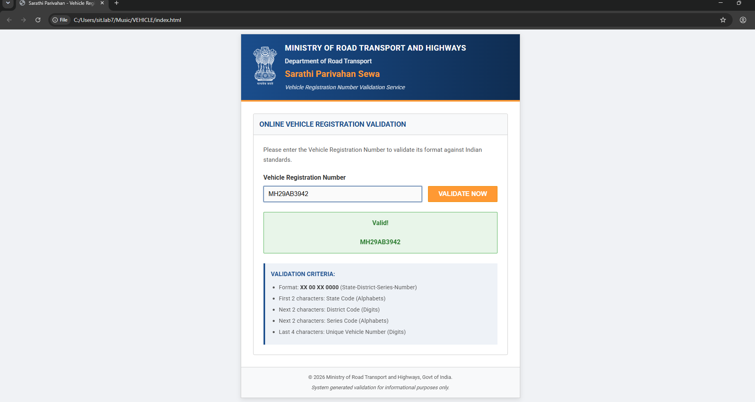
8. Result / Conclusion
The experiment and case study were implemented successfully. Functions, closures, scope, exception handling and DOM manipulation were demonstrated, and the vehicle registration validation worked as expected.

